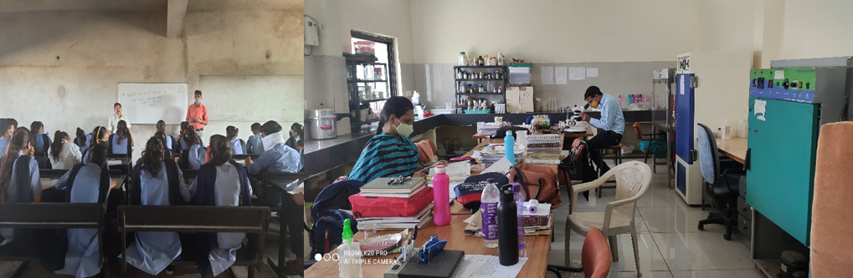
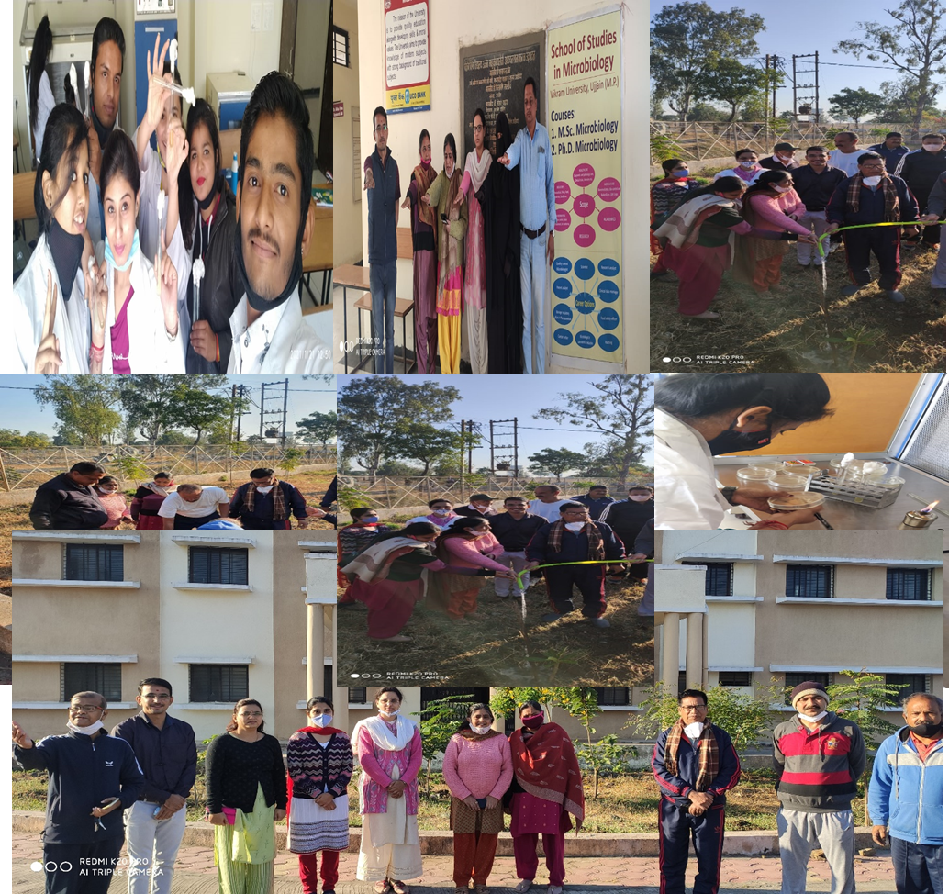
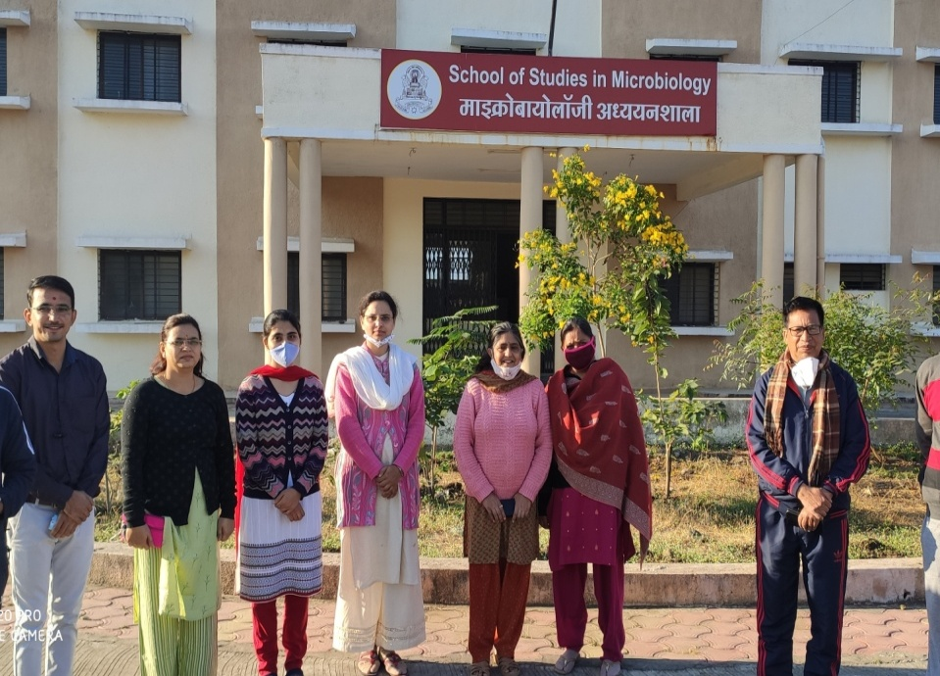
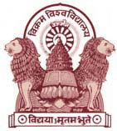
Course Offered:-
School of Studies in Microbiology, Vikram University, Ujjain
NAAC Accredited “A” Grade
Course | Eligibility | Duration | No. of Seats | Annual Fee (Rs.)  (excluding caution money)
B.Sc. (Hons.) Microbiology (CBCS) | 12th with biology as one subject | 4 Years (8 semesters) | 20 | 9500
M.Sc. Microbiology  (CBCS) | B.Sc. with Chemistry/ allied subject and two subjects of life science. | 2 Years (4 semesters) | 25 | 21021
Ph.D. Microbiology | M.Sc. Microbiology | 4-5 Years | As per norms | As per norms
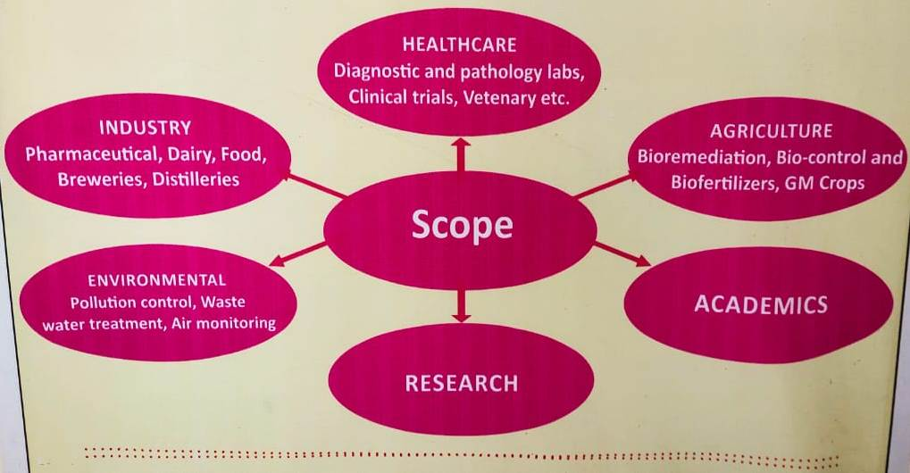
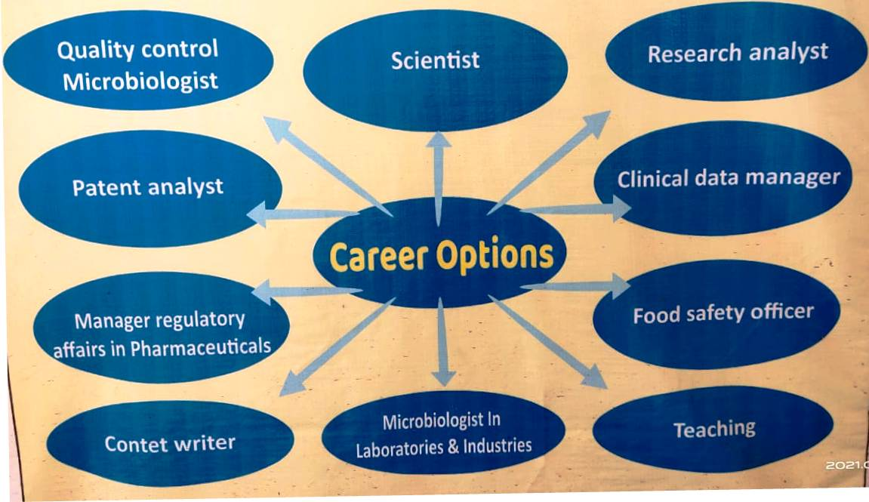
Contact Details:-
Dr. Alka Vyas Dr. S.K. Jain Dr. Preeti Das Mr. Rakesh Vyas
9425637184 9425336379 9893287830 9425906940

